Objective Questions
Q1) In analysing the hospital dataset with Power BI, ensure data cleaning to address inconsistencies and missing values before further analysis.
Answer:
- On the initial analysis the data types of the columns were checked to ensure the integrity of the data and in the dataset all the columns were in correct data types as per the schema.
- In the column, “patient sat score” there were null values and they could show error during further analysis so the null values in the columns were replaced with 0 to ensure the integrity of the data and avoid errors.
- Date column contains both date and time, so for the date and time were extracted from the columns for conducting the analysis.
- Dataset contains initial of the first name and last name, so for the efficiency both the columns were merged and new column “Patient Name” was created, which would help in analysis.
- New column “Gender” was created so that the gender name can specified to the symbols, i.e., M – Male and F – Female.

Q2) Assess the Average Waiting Time: Analyse the patient wait times to identify the average duration a patient spends before receiving care.
Answer:
Average duration a patient spends before receiving care = 35.26
Formula used: Average Waiting Time = AVERAGE ('Hospital ER (1)'[patient_waittime])

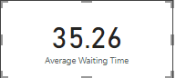

Q3) Visits by Department Referral: Calculate the total number of visits to each department based on referrals to understand which departments are most frequently visited.
Answer:
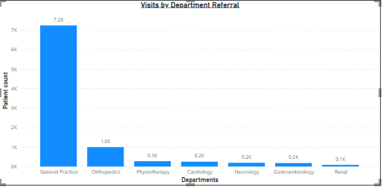

Insights:
- From the visual we can see the distribution of patients on the basis of visits to each department based on referrals
- General Practice department receives most of the patients (7.2K).
- Renal department receives least patients (0.1K).

Q4) Patient Visits by Age Group: Segregate patient visits according to different age groups to see which demographics utilize healthcare services the most.
Answer:
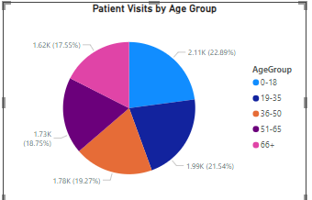
Insights:
- Patient count of different age group can be observed from the visual.
- Most number of patients are from the 0-18 age group (2110).
- 66+ age group has the least number of patients (1617).
Approach used:
- Age group column was created using the custom column feature of power bi and the patients were grouped on the basis of their age and custom groups were created.
- Formula used for custom column:
if [patient_age] <= 18 then "0-18"
else if [patient_age] <= 35 then "19-35"
else if [patient_age] <= 50 then "36-50"
else if [patient_age] <= 65 then "51-65"
else "66+"
- Column chart was created using the age group column and patient id column for the visualization.

Q5) Were there any Null values in the data? What would be the best way to handle these Null values and which approach have you opted for?
Answer:
- There were null values in the “patient sat score” column.
- There are several ways to handle the null values but each is dependent on the use case, if there are null values in numerical column like age then the average of the age values can be used to fill the missing values.
- The most general way to handle null values is to remove them but the problem would be that if the values are removed then whole row would be removed which might remove the important data which would not be the best approach.
- But in this case, removing null values in “patient sat score would also remove the important data, so I replaced the null values with 0 as most of the data has null values in the column because of which mean or average of the column would not be accurate and replacing with 0 would avoid errors in the analysis and can be used for the calculations.

Q6) Is there any relation between the number of visits and the Gender of the patients?
Answer:
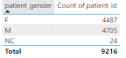

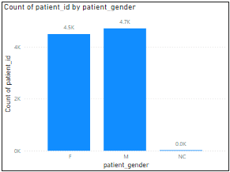

Insights:
- From the visual it can be observed that there is no relation between gender and number of visits.
- Both Male (4.5K) and Female (4.7K) have no significant difference between the number of visits, as for NC there is no mention of NC in the schema, so as per my judgement NC (24) would be the patients who might have forgot to mention their gender, even then there would no significant change as the count is very low.
- So, there is no relation between number of visits and gender.

Q7) Average Satisfaction by Demographics: Determine the relationship between patient satisfaction scores, their age groups, and racial backgrounds to pinpoint areas for improvement in patient experience.
Answer:
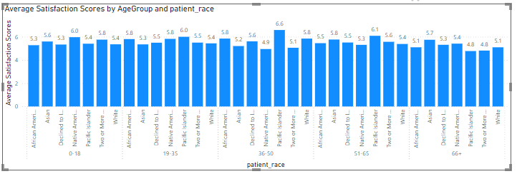

Insights:
- As most of the data provided had null values, so the average of satisfactory scores might not provide accurate ratings.
- So, the measure was created to calculate the average satisfaction score excluding the null values i.e., 0, because if all the ratings were included the average would be so low (around 1-2) which would have drastic negative impact on the reputation of the hospital.
- From the provided dataset, we can observe that the ratings scale is from (1-10) and the average is ratings are in the range of (5.47) which is very average rating and from the visual we can understand the the relationship between patient satisfaction scores, their age groups, and racial backgrounds and can make improvements in the patient experience.

Approach used:
- Previously created age group column and race column was used to create cluster column chart along with the average satisfaction score measure, using which we can observe the relationship between patient satisfaction scores, their age groups, and racial backgrounds.

Q8) The hospital's managing director seeks to evaluate the revenue of each department to understand how much revenue is generated by each.
Answer:
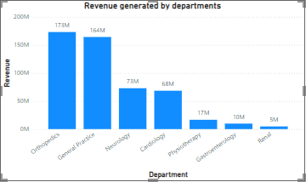
Insights:
- Revenue generated by each department can be observed from the visual.
- Orthopaedics department generates most revenue (173M).
- Renal department generates lowest revenue (5M).

Q9) Which department is charging the highest appointment fees in general? Use an aggregation DAX function to solve this question.
Answer:

Insights:
- Neurology department has the highest appointment fees (i.e., 1500).
Formula used: Department with Max Fee =
VAR MaxFee = MAXX(ALL(Sheet), Sheet[Appointment Fees])
RETURN
CALCULATE(
FIRSTNONBLANK(Sheet[department_referral], 1),
Sheet[Appointment Fees] = MaxFee)

Q10) Create a tabular visualization in the Report view which consists of Month-wise total visits in the hospital. Add a third column in the table that consists of the previous month’s total visits for each month’s row. Also, include a column that states whether the visits in a month are greater than that of the previous month's visits.
Answer:
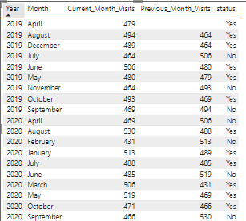

Insights:
- From the visual we can observe the visits of patients in the current month and also the number of visits in the previous month.
- On the basis of the visits, Status column indicates whether the number of visits has increased or not.

Q11) Using ‘Calculate’ and a row iteration DAX function calculate the total number of patients who have visited Dr. Smith.
Answer: Patient count for Dr Smith = 5986
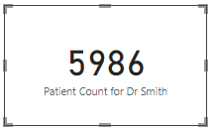
Formula used: Patient Count for Dr Smith = CALCULATE(COUNT(Sheet[patient_id]),Sheet[Doctor Name]= "Dr. Smith
Q12) Calculate the average age of the patients who visit the Orthopaedics department. Will the approach used to calculate this metric be different if the requirement had been all departments’ average age?
Answer: 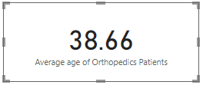

Formula used= Average age of Orthopedics Patients = CALCULATE(AVERAGE('Hospital ER'[patient_age]),'Hospital ER'[department_referral] = "Orthopedics")

Insights:
- Average age of Orthopedics patient = 38.66
- If the requirement was to find the average age of all departments, then there would be no need to use calculate function as the average age could be found directly using the average function as there were no conditions to be filtered and the formula would be something like:
- Average age of departments = AVERAGE ('Hospital ER'[patient_age])

Q13) Were there any data format issues in the data, and if there were/are how you handle them?
Answer:
- After analysing the dataset, no data format issues were found.
- The patient wait time was in number format but according to the schema numbers represented the wait time in minutes. So, no issues were found.
- Also new columns were created for the analysis and appropriate datatypes were provided to them.
- If there were any issues in the data format like the date and time columns were not having appropriate data types then I would have simply changed the data types to the correct format for ensuring the accurate analysis and avoid errors.

Q14) When we add a column in Power Query what’s the code that comes in M language in the formula bar? What do you know about M-query?
Answer:
- M-query is the language used in Power Query within Power BI for data transformation.
- It’s a functional language, meaning that it operates on functions and transformations to modify the data in queries.
- When you add a new column in Power Query, the code in M Language gets automatically written in the formula bar. This code is what Power Query uses to generate the transformation steps and it helps in monitoring the transformations.

Q15) Identify the top 5 doctors who generated the most revenue but had the fewest patients. (SQL)
Answer:
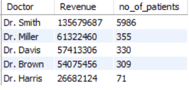

select `Doctor Name` as Doctor, sum(`Total Bill`) as Revenue,
count(distinct patient_id) as no_of_patients
from doctor
group by Doctor
order by Revenue desc , no_of_patients asc
limit 5;

Q16) Find the department where the average waiting time has decreased over three consecutive months. (SQL)
Answer:
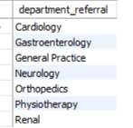
with cte as
(select department_referral, `date`,
round(avg(patient_waittime), 2) as average_wait_time
from hospital
group by department_referral, `date`),
cte2 as
(select department_referral, `date`, average_wait_time,
lag(average_wait_time, 1) over (partition by department_referral order by `date`) as previous_month_average,
lag(average_wait_time, 2) over (partition by department_referral order by `date`) as previous_2_month_average,
lag(average_wait_time, 3) over (partition by department_referral order by `date`) as previous_3_month_average
from cte)

select department_referral
from cte2
where average_wait_time < previous_month_average
and previous_month_average < previous_2_month_average
and previous_2_month_average < previous_3_month_average
group by department_referral;

Q17) Determine the ratio of male to female patients for each doctor and rank the doctors based on this ratio. (SQL)
Answer:
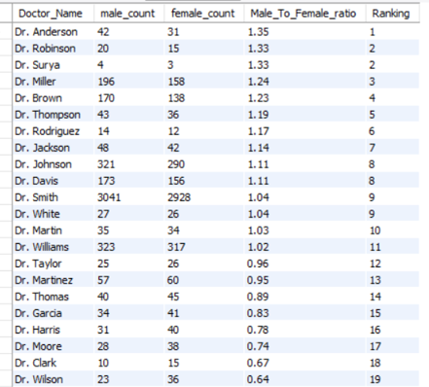
with cte as
(select d.`Doctor Name` as Doctor_Name,
sum(case when h.patient_gender = "M" then 1 else 0 end) as male_count,
sum(case when h.patient_gender = "F" then 1 else 0 end) as female_count
from hospital h
inner join doctor as d on h.patient_id = d.patient_id
group by Doctor_Name),
cte2 as
(select Doctor_Name, male_count, female_count,
round((male_count/female_count),2) as Male_To_Female_ratio
from cte)
select Doctor_Name, male_count, female_count, Male_To_Female_ratio,
dense_rank() over(order by Male_To_Female_ratio desc) as Ranking
from cte2;

Q18): Calculate the average satisfaction score of patients for each doctor based on their visits. (SQL)
Answer:
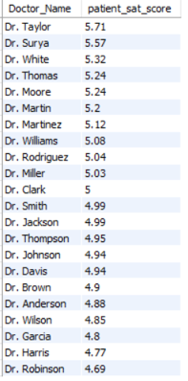
select d.`Doctor Name` as Doctor_Name,
round(avg(case when h.patient_sat_score = "" then 5 else h.patient_sat_score end),2) as patient_sat_score
from hospital h
inner join doctor d
on h.patient_id = d.patient_id
group by Doctor_Name
order by patient_sat_score desc;

Q19) Find doctors who have treated patients from different races and calculate the diversity of their patient base. (SQL)
Answer:
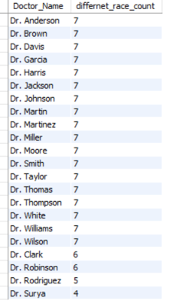

select d.`Doctor Name` as Doctor_Name,
count(distinct h.patient_race) as differnet_race_count
from hospital h
inner join doctor d
on h.patient_id = d.patient_id
group by Doctor_Name
having count(distinct h.patient_race) > 1
order by differnet_race_count desc;

Q20) Calculate the ratio of total bills generated by male patients to female patients for each department. (SQL)
Answer:
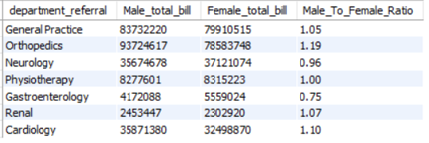
select h.department_referral,
sum(case when patient_gender = "M" then d.`Total Bill` end) as Male_total_bill,
sum(case when patient_gender = "F" then d.`Total Bill` end) as Female_total_bill,
round(sum(case when patient_gender = "M" then d.`Total Bill` end) / sum(case when patient_gender = "F" then d.`Total Bill` end),2) as Male_To_Female_Ratio
from hospital h
inner join doctor d
on h.patient_id = d.patient_id
group by h.department_referral;

Q21) Update the patient satisfaction score for all patients who visited the "General Practice" department and had a waiting time of more than 30 minutes. Increase their satisfaction score by 2 points, but ensure that the satisfaction score does not exceed 10. (SQL)
Answer:
update hospital
set patient_sat_score = least(patient_sat_score + 2,10)
where lower(department_referral) = "general practice" and patient_waittime > 30;

